Registration and LOG IN

SWIM Registry Usage Scenarios

Overview
This usage scenario covers the registration process.

UC001: USER REGISTRATION

Precondition
None

Outcome
The user obtains credentials to access the registry.

User Interaction
The user needs to execute the following actions.

Access SIGN-UP Page
The user needs to:
- Go to registry home page https://eur-registry.swim.aero/ and follow the link for Log in or Sign-up.
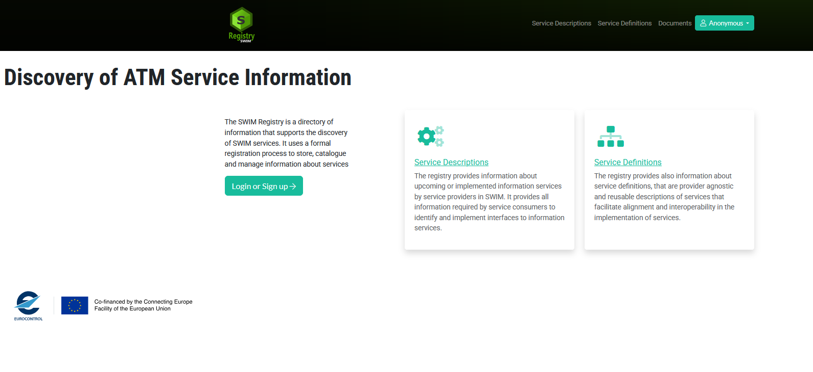

SIGN UP
The user needs to click on the “Create new account” tab:
- Provide an email address (note that registrations with personal email addresses will not be accepted)
- “Full name” information
- Optionally, a justification for the registration
- Fill the “Requested Organization” field
  - This represents the name of the User Organization. It is labeled as “requested” since the Registry Administrator will use this information to assign the user a “normalized” name for its organization (e.g. such as to avoid differences in capital letters and/or spelling mistakes for a same organization across different users)
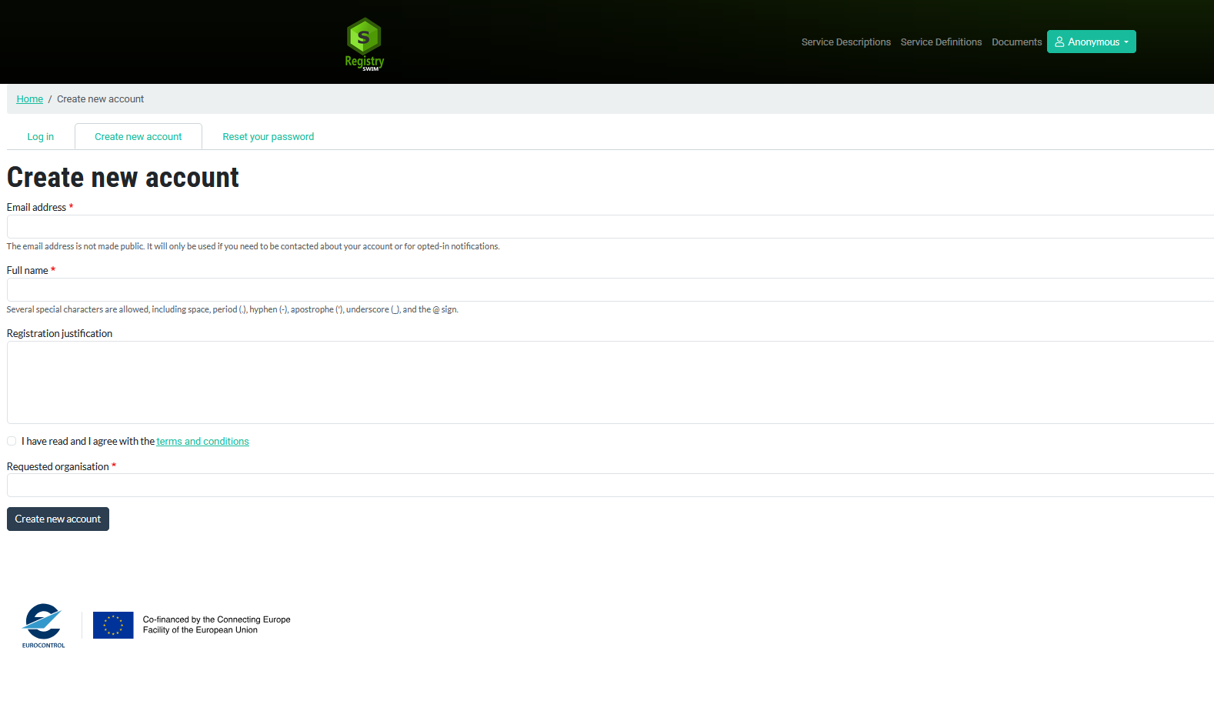
After Registry Admin approval, the User will receive an email at the address provided during sign-up similar to:
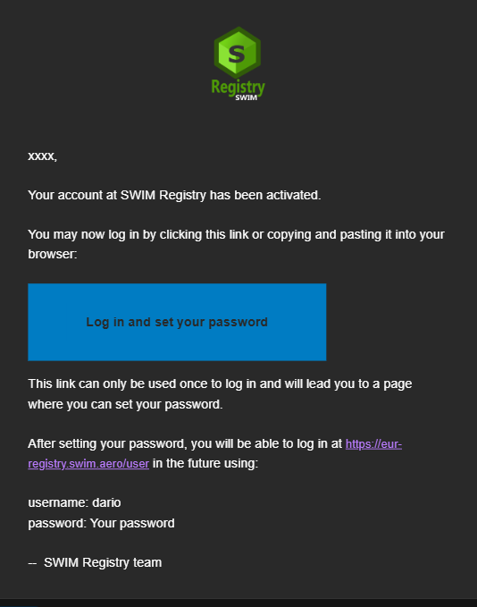
Click on the link to set a password and log-in to the Registry.

Overview
This usage scenario covers the log in process.

UC002: LOG IN

Precondition
The user requires an account as explained in the User Registration Scenario.

Outcome
The user logs in to the registry.

User Interaction
The user needs to execute the following actions.

Access LOG-IN Page
The user needs to:
- Go to registry home page https://eur-registry.swim.aero/ and follow the link Log in or Sign-Up.

LOG IN
The user needs to:
- Provide UID/PWD and log in.
