Register and edit a service

SWIM Registry Usage Scenarios

Overview
This usage scenario explains how to register and edit a service of your organisation

UC001: Register a new service

Precondition
Logged in
Being a Service Description Editor for your organisation
Your organisation is registered

Outcome
Please contact Registry Administrator if you do not have the right role or your organisation is not registered

User Interaction
The service description editor needs to execute the following actions.

Register a new service
The editor needs to:
- Expand the User Menu on the top right of the page and select “Add Service Description”:
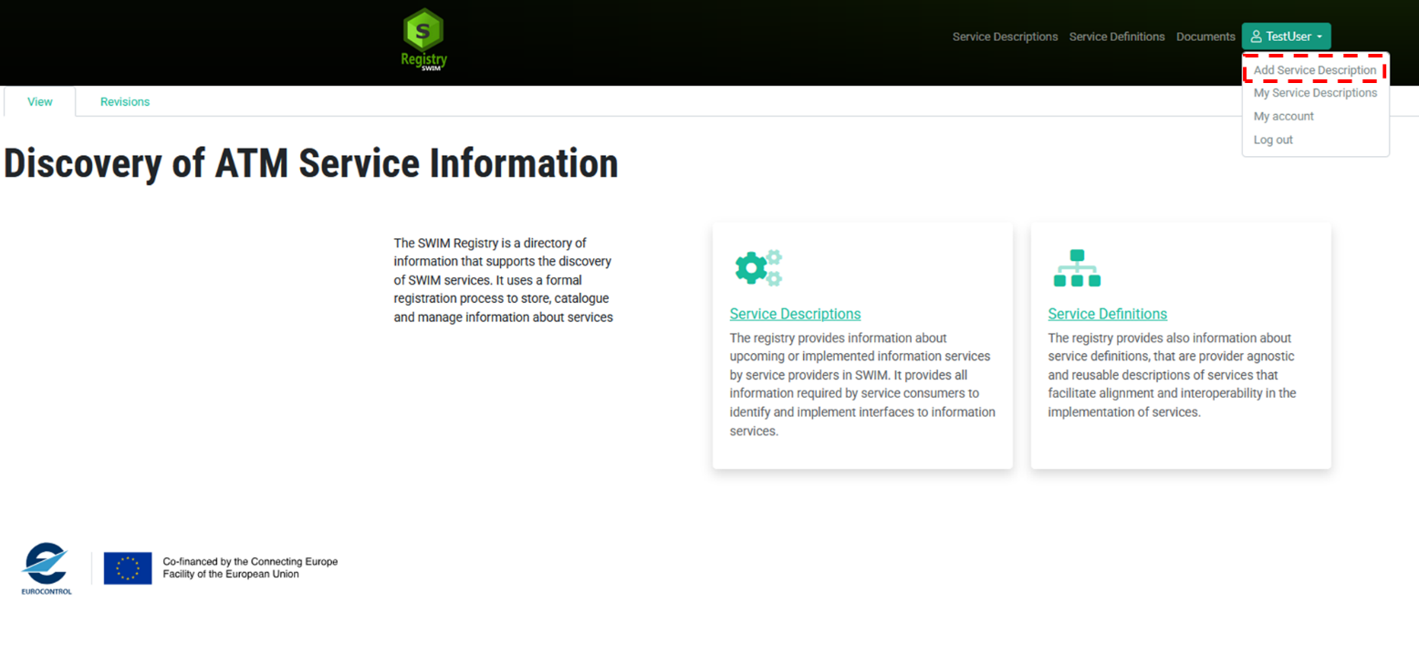

Provide the required information
The editor may choose two options to create the new Service.
- If the Editor has already prepared – offline - a JSON representation of the Service, he can directly upload the file clicking on the “Browse” button:
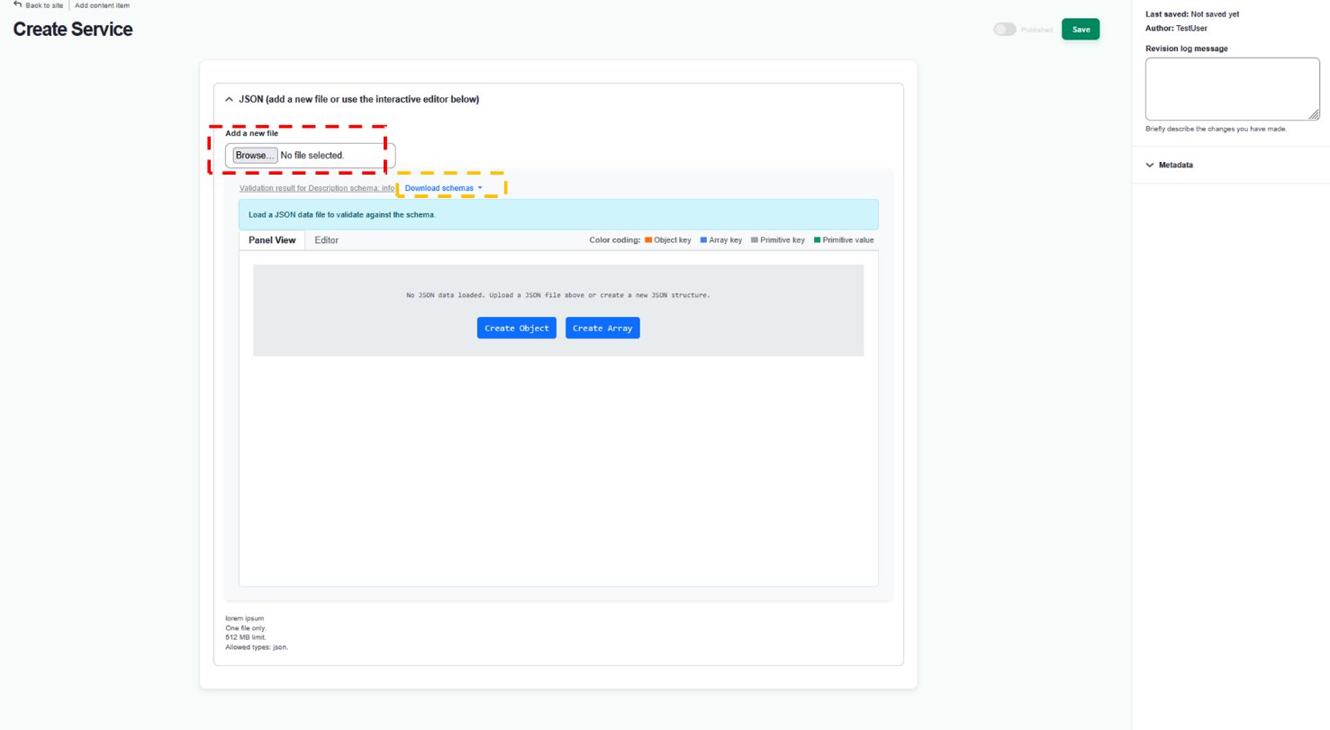
Note that, in such a case, the JSON file is expected to be valid with respect to the Service Description Schemas. The schemas can be downloaded expanding the “Download Schema” dropdown. These are composed by 3 files with “Description.json” being the “root” with references to objects defined in the other two.
Once uploaded, the content of the file will be shown in the two views on the Panel below the button:
- Panel view allows to navigate the content of the file using a tree like view extending horizontally while navigating the tree
- Editor view provides an online JSON Editor pre-configured with the relevant JSON Schemas to facilitate editing (e.g. pressing “CTRL”+”space” on the keyboard with suggest the relevant properties to be added depending on the position on the JSON tree – pressing F1 will show all possible commands available) and/or correction of validation errors.
- The Editor may also directly start Service editing from the Panel View. On this respect, it is suggested to use the “Editor” tab since, as previously indicated, it provides suggestions regarding the properties to be used.
NOTE: The Editor can save its work at any time. Anyway, since he is only able to edit services for organisations for which he has been authorised, he should always ensure – before saving – to include the “serviceProvider” object in the JSON and filling its “name” property. That name must correspond to the name of one of the organizations for which the editor has the “service description editor” role. It is also suggested, as a minimum, to include the “serviceIdentification” object as it holds the name and version of the service being created.
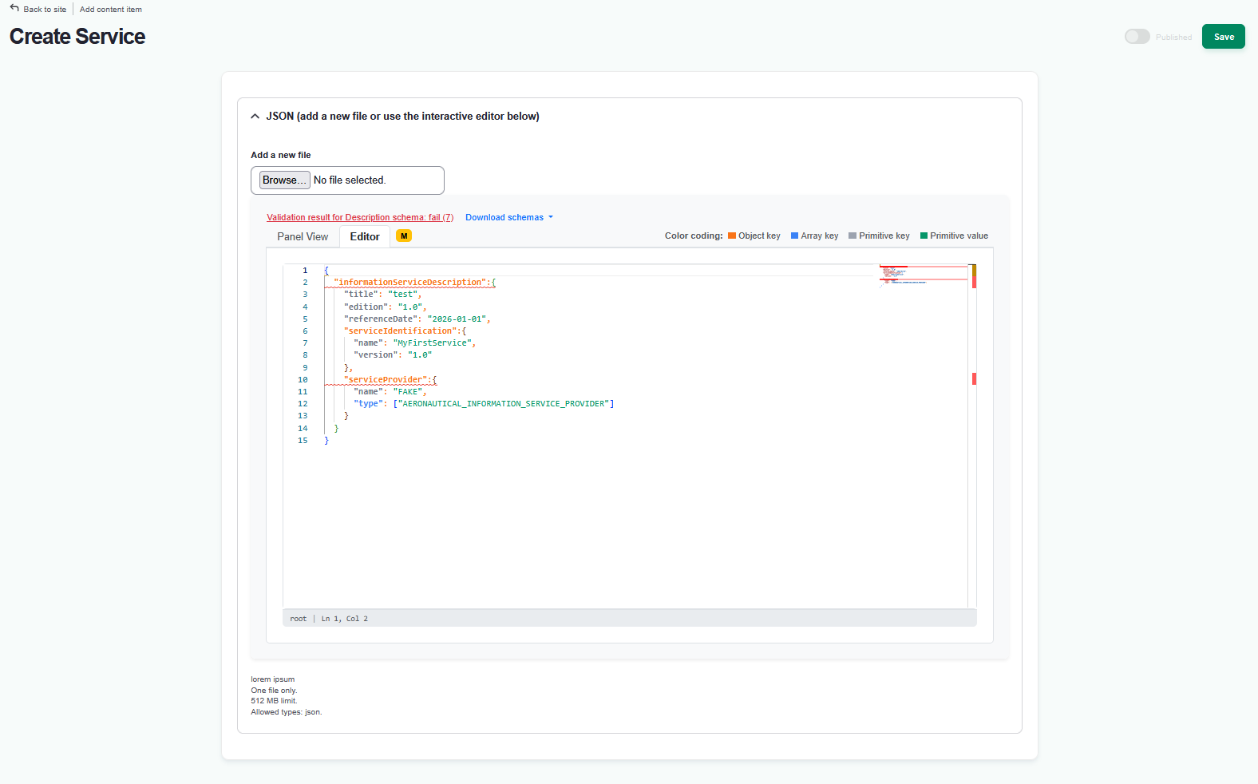
In both cases, the result of the validation will be shown on top of the Panel/Editor views. In case of validation errors, their details can be seen by expanding the Validation result message (as shown in the figure below):
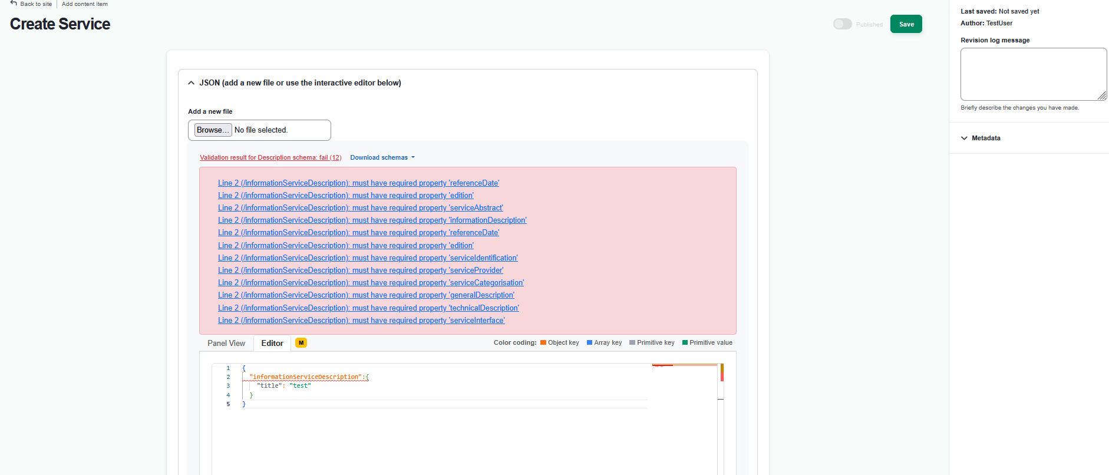

NOTE: please collapse all filed on the right hand side in the METADATA section.
Under Publication Scope the Editor can choose the level of restriction:
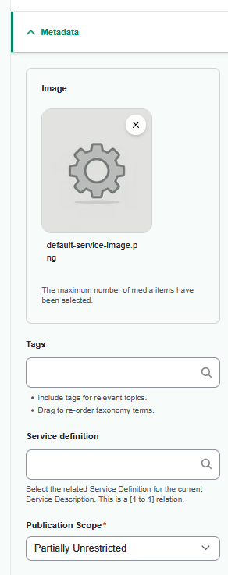
Unrestricted: All information will be visible to unauthenticated user on the homepage (i.e. without log in).
Partially Unrestricted: Contact details will be hidden from the unauthenticated user, but other information about the service will be visible on the homepage.
Restricted: All information about the service will only be visible to authenticated user
Other metadata that can be provided are:
- Image: It represents a service “logo” that will be shown when the service is accessed and in the service listing view.
- Tags: It is possible to attach pre-defined (by the Registry Administrator) tags to the service. Such tags will be shown on the service listing view and when the service is accessed. Clicking on the “Tags” textbox will display the available choices together with their description.
- Service definition: It is possible to indicate that the service is conformant to a given Service definition already published on the Registry. Clicking on the textbox will display the available choices.
As already indicated, the Service can be saved at any time. Anyway, while it is not “valid” (i.e. it does not pass JSON Schema validation) it will not move to “Published” state and will remain in “draft”.
Only when the Service will pass validation, the Editor is allowed to “Publish” the service (i.e. make it publicly visible to other users). In this case, the “Published” toggle will be enabled and the Editor will be able to activate it.
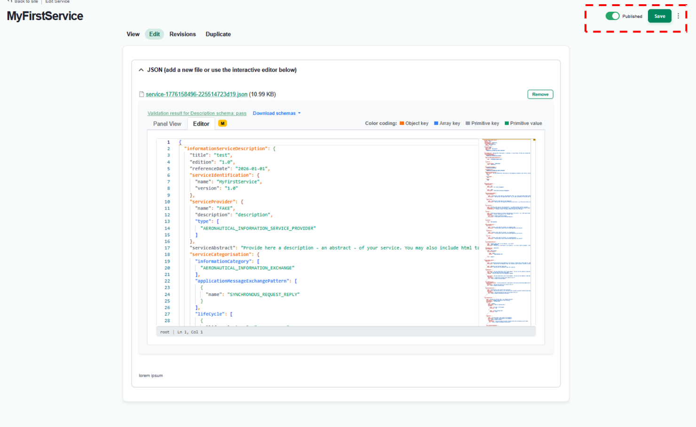
After saving the Service, the new Status will be activated, so the Service will move from “draft” to “Published” state.

UC002: edit a registered service

Precondition
Being a Service Description Editor for your organisation
Your organisation is registered
You have registered at least one service

Outcome
- Service information can be modified
- Service Status can be modified

User Interaction
The user needs to execute the following actions.

Edit service information
Go to the service and click on ‘Edit’ tab:
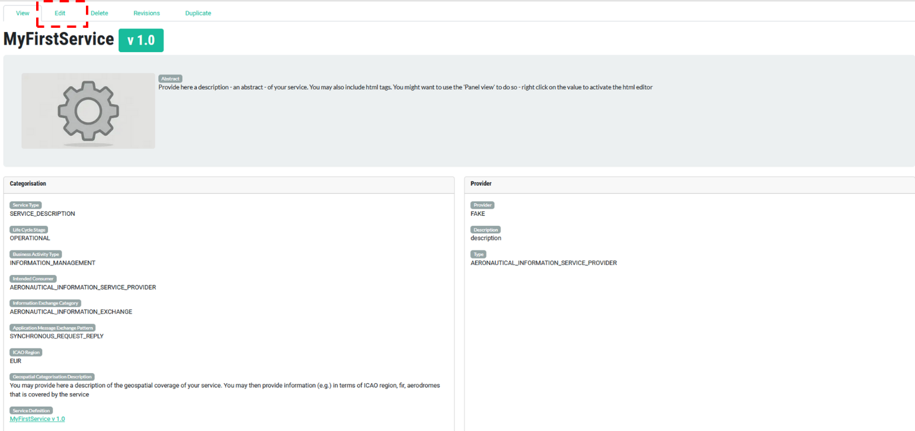

The Service Editor can use one of the two available tools to update the JSON representation of the Service.
He can use the “Panel view” or the “Editor”.
The “Panel view” can be more convenient when the Editor just needs to update the value of properties already present in the JSON. In fact, by right clicking on a property, it is possible to directly update its content. In most of the cases (when the property represents some kind of description), a simple HTML menu will be shown allowing introduce RTF formatting (e.g. bold characters, italics, bullet points etc..).
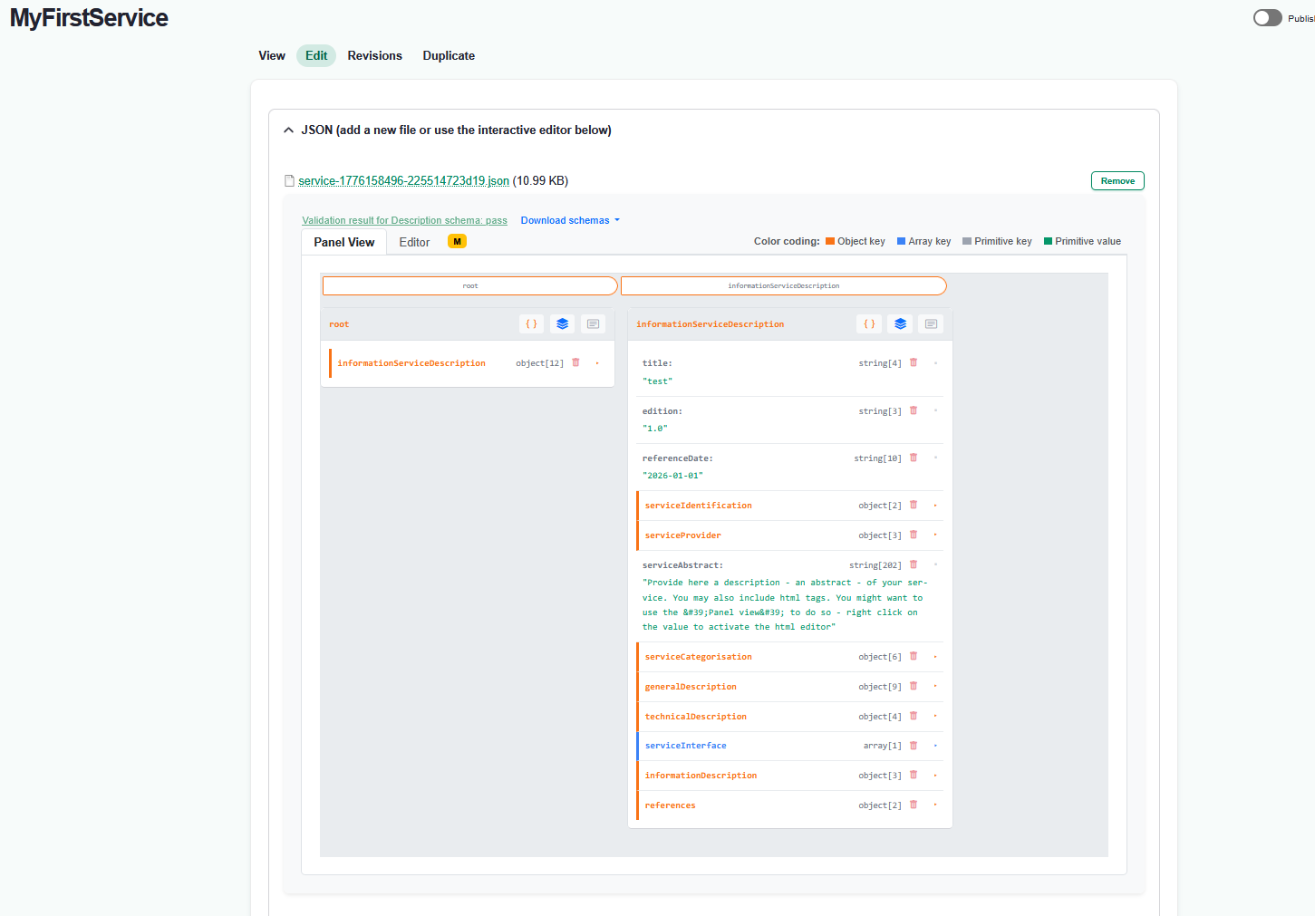
When additional content needs to be included, it is more convenient to access the “Editor” tab. In this way, the Editor may benefit from the suggestions provided by the JSON Editor (accessible pressing “CTRL”+”space” on the keyboard).
While updating the Service, it is advised to change the deactivate the “Published” toggle on the top right such as to change the status of the service in “draft” (note that the status will change only after saving).
In any case, in case the service is saved while containing validation errors the status of the service will be automatically moved to “draft”.
Click Save when done.
Service can also be Deleted when needed!

